Test #1 : Visuals on each page

1. Sign in/Sign up page  
   -The stars behind the main title fidget a bit every 5 (approximately) seconds 🡪 is hard on the eyes  
   -test button on left side (Georges already mentioned this will be fixed, however it is being noted here in case it is overlooked)
2. Create Account  
   -The form to select courses has a lot of repetitive entries (as well as entries that don’t belong)
3. Once you’ve logged in, the apge that displayes your schedule  
   -click modify schedule  
   -the schedule now looks like this (overlappingwith the white area) :  
   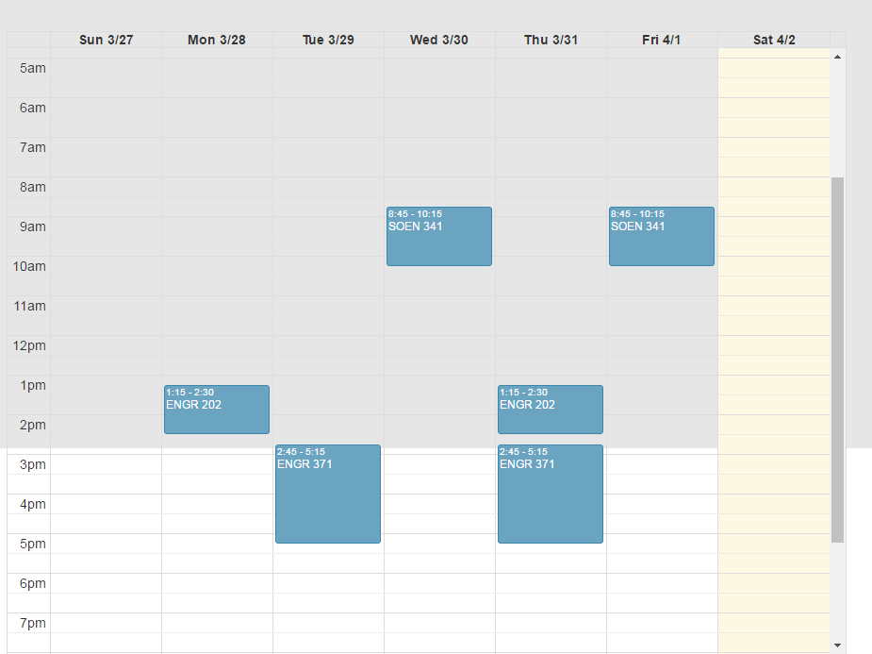

Test #2: Functionality

1. Create Account

-The user should not be allowed to enter numbers into their name (they are)   
-Once a valid account form is filled in, the user is redirected to a page: 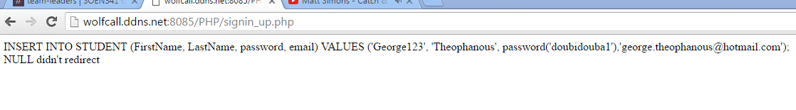

The only way for the user to go back is to press the abck button on their browser. The account creation itself works however.

1. “The Force” homepage after you’ve logged in  
   -HEADER:  
   --“THE FORCE” button at the top redirects to 404  
   --No “About” page  
   --No “Contact” page  
   --Account button works (see “account page” test for details)  
     
   -Body of page:  
   --“Select Semester” dropdown does not seem to affect the schedule displayed  
   --At the bottom of the page there are 2 submit buttons   
   ----The second one redirects to a 404 and should be removed.  
   ----The first one seems to be for submitting a new schedule. The search bar should be removed as it is confusing  
   -“Modify Schedule” brings down a form (good)  
   ----This form however does not seem to have any functionality
2. “My Account”   
   -Maybe display the user’s current information to avoid confusion?   
   -Maybe don’t allow the user to input the same password as before?  
   -password change does not actually work   
   -Account information changes do not work properly  
   -wrong courses are displayed in the box on the right  
     
     
     
     
     
   **LEGEND FOR IMPORTANCE OF ISSUES**

GREEN : NOT IMPORTANT FOR NOW, GO OVER THESE AT THE END  
ORANGE : ISSUES SHOULD BE LOOKED AT ONCE THE MOST IMPORTANT ONES ARE TAKEN CARE OF  
RED: VERY IMPORTANT, FIX THESE ASAP  
  
  
**FINAL COMMENTS**

-One of the big reasons the header buttons not working is important is that it ruins the users’ experience since they cannot easily navigate back. Maybe implement a “breadcrumbs” div that links users to past visited pages (JUST A SUGGESTION< NOT MANDATORY)